Testing and Evaluation

Multiple tests were conducted to increase the success rate of our product.

Real-life tests were also video recorded as proof and is attached in the folder document.

Some proofs of product being trained and tested are:

# Detecting plate from an image

Import all the dependencies first, then the next cell code will import the image through file name that you want to run in our system. The other cell starts to perform image detection.

When it is successfully run, the number place will be successfully detected. It will perform better than other traditional methods as the model had trained for 10,000 steps.

In the figure you can see how our region of interest (ROI) which is our license plate is detected with an 88% accuracy which is considerably very good.

# 

Eventually, after the code has been successfully run and model has trained for a complete 10,000 steps the message should be like shown in Figure. It takes a lot of time to train but the more the model is trained, the more accurate results it will generate.

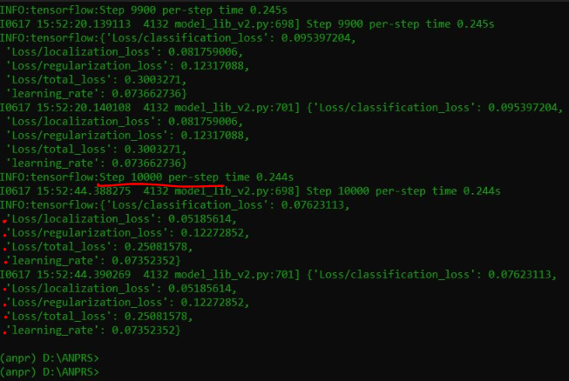

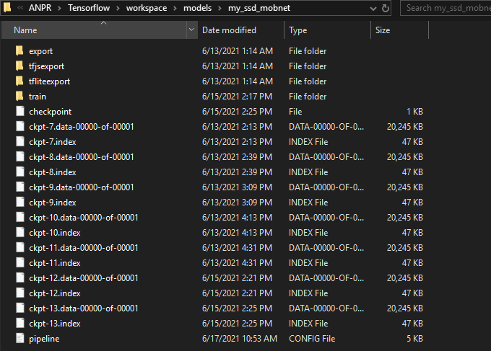To check if the model trained successfully, we go into the folder my_ssd_mobnet located in ANPR/Tensorflow/workspace/ models/my_ssd_mobnet.

We can see all the checkpoint proofs (Figure). This ckpt index file is the latest instance of our trained model.

# Real time detections from video cam

The code will open up a connected video camera, in our case connected webcam and from there it will accurately detect the license plate in real time. It will extract

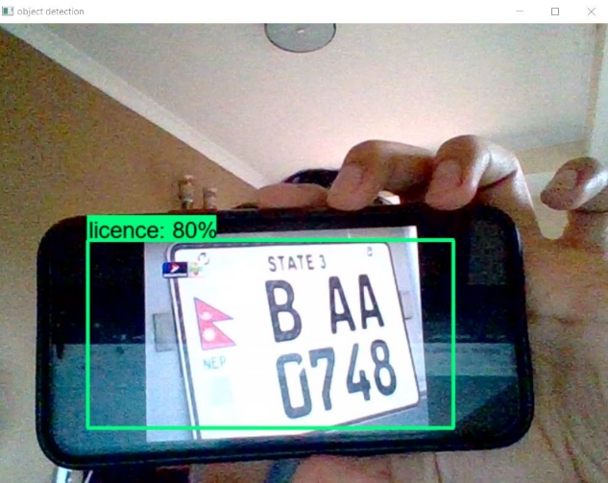

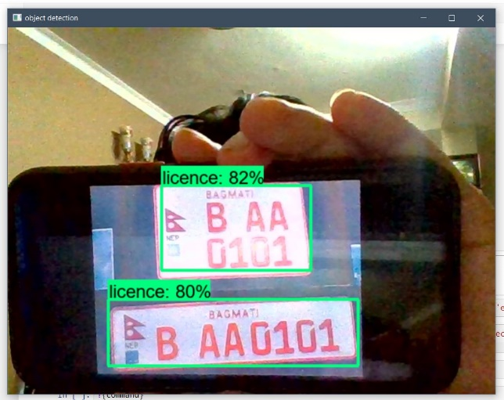

# Displaying results

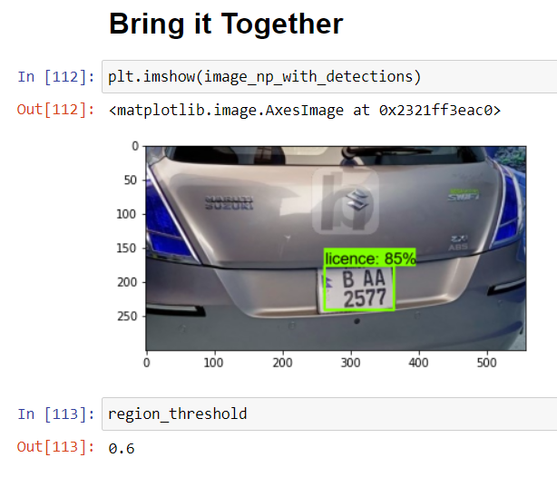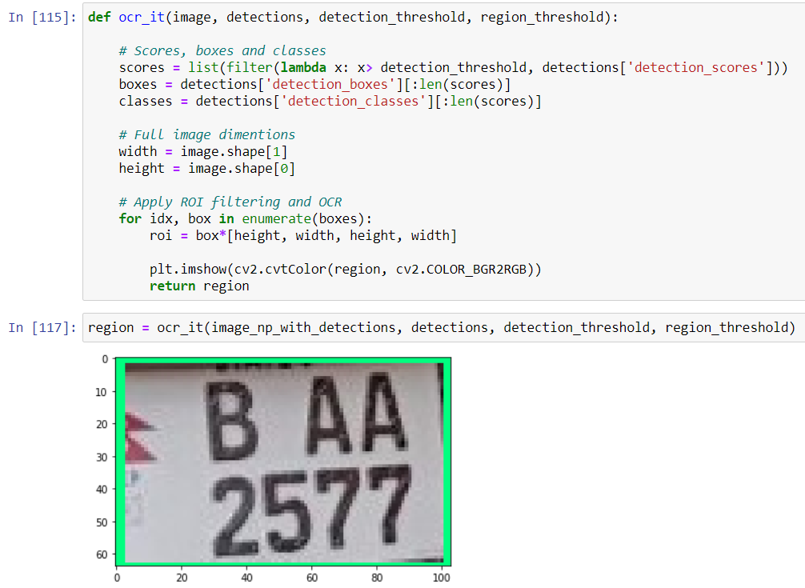

* 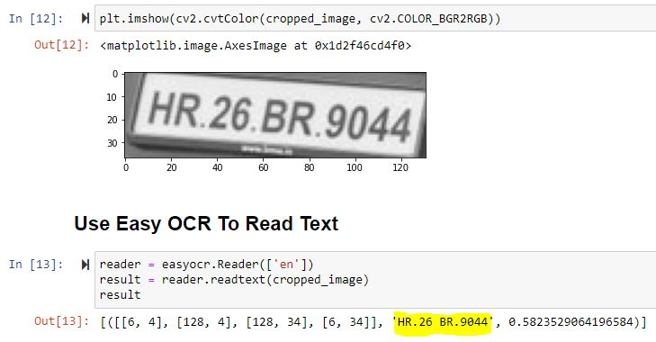**OCR Character reader reads the character from the license plate and shows the result.**
* **Result generated by OCR will also be displayed on the original image.**

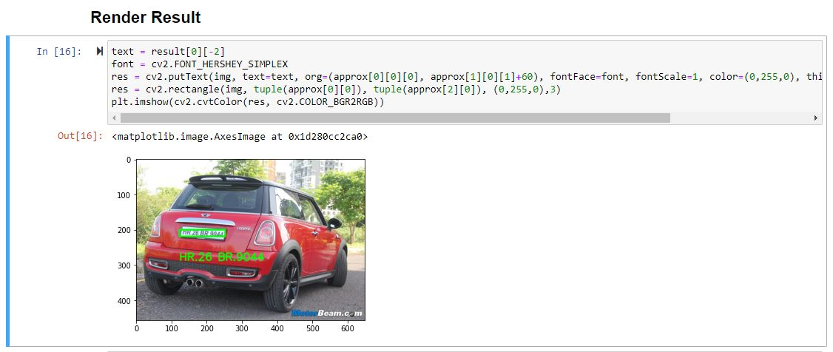

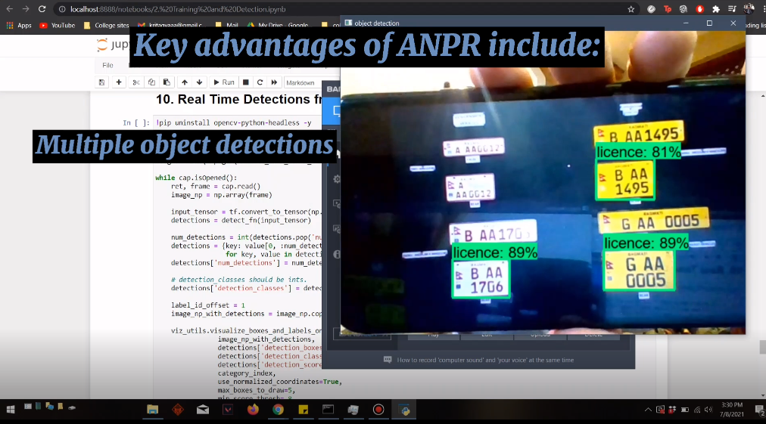**Multiple detections test in real time**

**Night detections in real time**

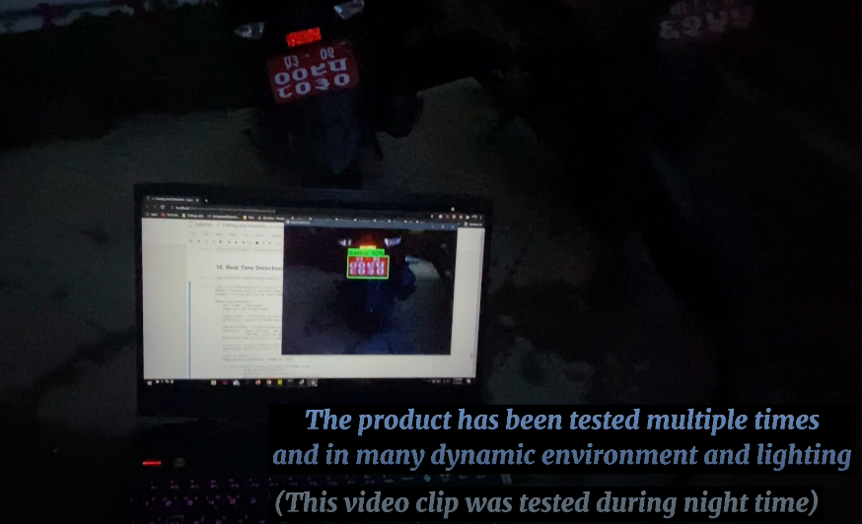

**Stability detections test in real time**

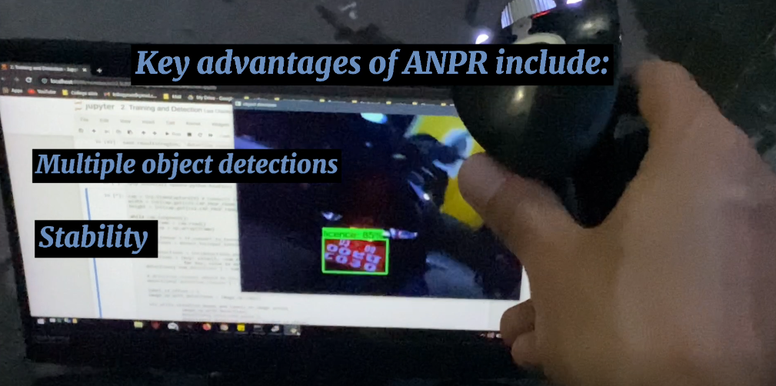

**Dynamic detections in real time**

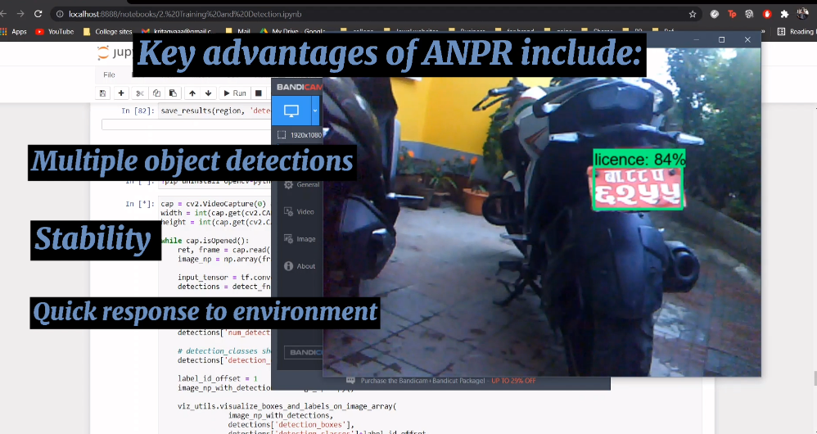

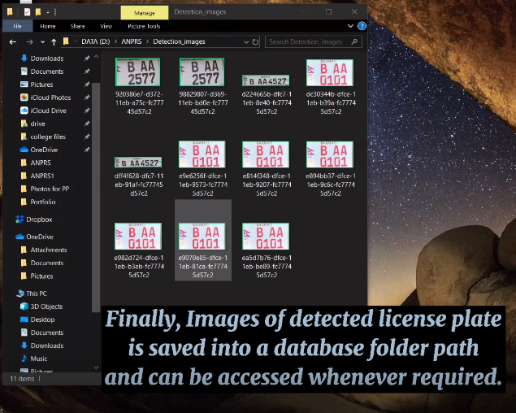**Saving detected license plates (ROI)**

**Saving detected license plates details (ROI)**

